“There you are!” said Dad.
He was standing in the middle of the library, a book open in his hands.
I stopped in the doorway, staring.
Before the morning was over, I’d see some pretty amazing things in this mansion, but none more jaw-dropping than the library. Books stretched from floor to ceiling, stacked on towering shelves that reached two stories high. Catwalks ran between them, and sunlight from enormous arched windows created these majestic sunbeams…it was like I had stepped into Hogwarts, or maybe the lair of some well-read villain in an old James Bond movie.
It was such a perfect room…I couldn’t believe more people weren’t crowded into it. At the moment it was just Grandpa and me and a sign in the middle of the room that read: ALL BOOKS FOR SALE – PRICES AS MARKED.
Dad closed his book. “What took you so long?”
I held up the robot kit. “Got distracted. Found this outside.”
He squinted at the box, then laughed. “A build-your-own-robot kit! What a coincidence!”
“Coincidence?” I said.
Dad showed me the hardback he’d been reading. “I just picked out this book,” he said. “I thought you might like it.”
He turned it toward me.
<sketch>Simple Robots for Clever Humans by Sparky McVoltage </sketch>
“Sparky McVoltage?” I said.
“Sounds really…electrifying. Don’t you think?” Dad said with a grin.
I let out a chuckle.
“I mean, for all we know, this book might be…shocking.”
“Okay, Dad.”
“It’s an old book but yet somehow still feels very….current.”
“Stop.”
Now we were both laughing. “Seriously,” Dad said, “looks like you and I were on the same page this morning. Seems you are about to enter your robot era.”
“I was thinking maybe you could help me with this?” I said.
He didn’t respond.
“Or Grandpa?”
“I bet your grandpa would love nothing more than to build a robot with you,” said Dad. “That’s a cool idea.”
It was a really cool idea, actually, and I was excited to text Grandpa later today.
Dad put his hand on my shoulder, and the two of us stood for a bit, enjoying the quiet of the library. Looking at the books, all of them old and majestic and…smart.
“Can you believe this place?” Dad said. “Every single one of these shelves is full of books about science and engineering. Some of these books are newer, like Sparky McVoltage here, but many are over a hundred years old.”
He ran a hand reverently along a shelf labeled Physics: Volumes I–XII. “The man who owned all this, Marvin Marindale, was a genius. Eccentric as they come, but brilliant.”
“I’ve heard his name before,” I said. “But I don’t know where.”
“You can’t go very in Brimley Forge without hearing his name,” Dad said. “His foundation paid for all kinds of things in our town, from parks to schools to libraries.”
“That’s where I’ve heard of him,” I said. “His name’s on a plaque in the lobby of the Atlas Library.”
Dad nodded. “Indeed it is. Funny you should think of that. Might be the only library in town more impressive than this one.”
“How did he get so much money?” I asked.
“He was born with some of it,” Dad said. “The Marindales were an old silver mining family. But Marvin took it much further. When he was young, in his twenties, he built one of the first working models of artificial intelligence.”
“Seriously?” I said.
“Seriously,” said Dad. “Way ahead of his time. He licensed his invention to the Tanthrop Hammond company, and now, well…you’ve seen what’s happened. AI is everywhere now, in everything, and Marvin got royalties whenever his version was used. Made him one of the richest people in our state, and for the most part he used that money for good, I think.”
“So he was a good guy,” I said.
“I think so,” said Dad. “Except…toward the end of his life, he went a little, well…”
Dad twirled a finger near his temple.
“He went crazy?”
“I prefer to say eccentric,” said Dad. “He became obsessed with theories no one could make sense of. Wormholes, quantum entanglement, time distortion. Brilliant ideas, maybe, but no one could follow him. He grew reclusive, stopped coming to town. By the end, he never left Hammerstrike.”
“And then he died?”
“Yes, apparently he’d been sick for awhile. His nephew cared for him at the end. In his will, he left everything—the mansion, his fortune, even this library—to the Marindale Foundation, which is why everything is for sale today.”
I looked around at the library. The place hummed with quiet energy, like all the thoughts inside these books were still alive, whispering to each other.
“So this sale is all for charity,” I said.
“That’s right,” said Dad. “Everything we buy here today goes to the Marindale Foundation, which spends all its money making our town a nicer place.”
“That’s nice, I guess,” I said.
But even as I said it, I felt a little sad. There was something special about this library. It felt like there was enough knowledge here to unlock the secrets of the universe, and soon it would all be scattered, broken apart, boxed up and sold.
Dad patted me on the back. “Come on, let’s see what else is here. It sounds like the best stuff is all upstairs.”
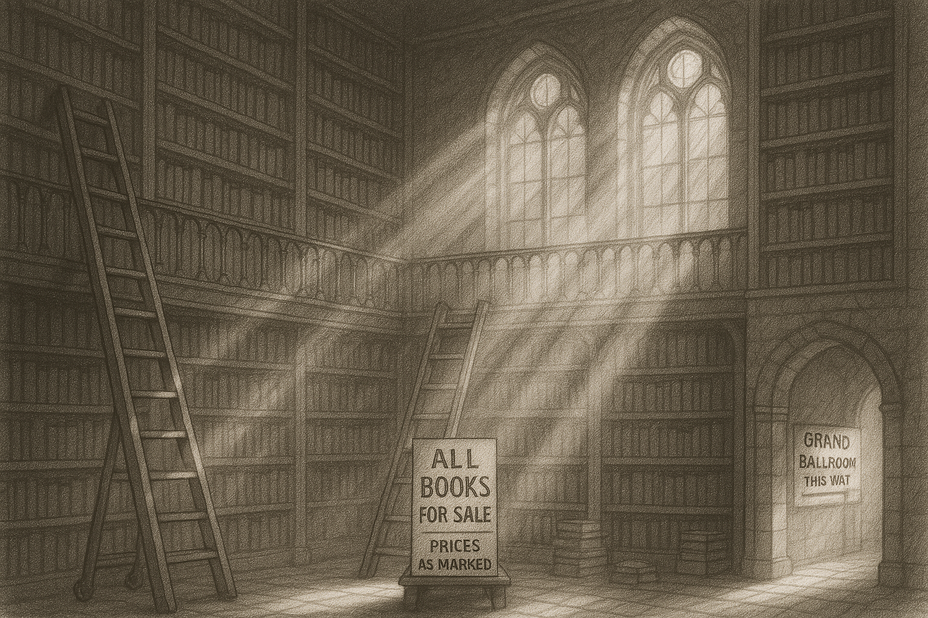

(scene break – illustration of library with Grand Ballroom this way signs)
We left the library and followed the signs pointing to the grand ballroom.
The arrows on the signs took us down a long hallway, then up a narrow flight of creaking stairs.
We emerged in a cavernous space, enormous, bigger than the gymnasium at my school. Crystal chandeliers hung from a dizzyingly high ceiling. Rows of tall arched windows lined the walls, looking out over all of Brimley Forge.
“Whoa,” I said softly.
Unlike the library, the ballroom was crowded. Rows of long tables filled the center of the floor, each one buried under piles of old things: vinyl records, glass bottles, vintage radios, old electronics equipment and computers. The air buzzed with voices, the clink of glass, the rustle of paper. It felt like half the town was here.
I was scanning the tables when I heard someone shout my name.
“Hey, Gavin!”
I turned and spotted Mateo Torres, my best friend, half-buried in a table piled high with knick-knacks and old clothes. He ran towards me, holding what looked like a rolled-up poster in his hands, grinning like he’d just uncovered buried treasure.
“Check this out!” he called, unrolling the poster with a dramatic fwump.
The print showed a cartoon pizza delivery guy rocketing through outer space, a steaming pizza box balanced on one hand, stars and planets whizzing past in pixelated streaks of neon. Across the top, in chunky retro text, were the words:
GALAXY PIZZA DELIVERY.
“Vintage video game art!” he said. “Tell me this isn’t the coolest thing you’ve ever seen!”
It was, actually, really cool.
And…familiar? Had I seen this game before? Something about the galaxy in the background…
Whatever. The poster was amazing, and I could already picture it hanging in Mateo’s room, right between his posters of Castlevania and Moon Patrol.
(show sketch of poster)
All my friends and I were video game enthusiasts, but Mateo was a level up from all of us. He was captain of the eSports team at school, had a deep, encyclopedic knowledge of the history of video games, and if you asked him what he wanted to be when he grew up, he said, without hesitation, I’m going to be a video game designer.
Which was so much cooler and more hardcore than all my other friends who wanted to be streamers. Being good at playing games was cool, but being able to make them? Way cooler.
“You ever heard of this game?” he asked.
I shook my head. “No, and I’m surprised, because it looks kind of awesome.”
Mateo held it up to the light. “This might be a collector’s item,” he said. “And they’re selling it for a dollar. Can you believe that? This is worth at least ten, minimum. Not that I’m gonna sell it. Who would sell something like this?”
He paused mid-ramble, noticing that I, too, had found something cool.
“Wait, what’s that?” he said, pointing at the box under my arm.
I smiled big, already excited about the adventures Mateo and I were about to have.
“I found it outside,” I said, holding it up for Mateo to see. “You and I are gonna build a robot.”
Mateo’s eyebrows shot up. “Heck yeah we are.”
(scene break – illustration of the galaxy from the poster)
Excited about our new finds, Mateo and I drifted deeper into the ballroom, weaving through the maze of tables, listening to the buzz of voices and laughter.
The place was full of familiar faces. Classmates, neighbors, people you saw so often you stopped remembering where you knew them from. I saw my science teacher, Ms. Ehlo, who smiled and waved at me. I also saw my social studies teacher, Mr. Stefaniput, who pretended not to notice me.
Brimley Forge was big enough that you didn’t know everyone, but not so big that everyone was a stranger. Of course, if you’re lucky, you’ll see someone you actually want to see, which is what happened at that moment for me and Mateo.
Because just down the way, our friend Charlotte had burst into the ballroom through the far doors. She spotted us instantly and started waving both arms over her head, motioning for us to come quick, like she’d been waiting all morning for us to finally show up.
This was classic Charlotte, by the way. Always in motion. Always ready for an adventure. If you spent enough time around her, you couldn’t help but catch the vibe. Her energy was contagious. Mateo and I loved hanging out with Charlotte because, when you were with her, the world felt exciting and full of possibility.
And honestly, I have no idea why she liked hanging out with us. But she did.
“Hey! You guys have to see this!” she called, already hurrying toward us, her sneakers squeaking on the polished floor.
“See what?” Mateo asked.
She was out of breath when she reached us. “The sunflowers,” she huffed. “There’s something weird about the way they’re planted, or maybe the way they’re growing. I don’t know, just…you have to see! Come on!”

Because just down the way, near the end of the ballroom, stood our friend Charlotte. She saw us at the same instant we saw her, and she tossed the pile of scarves in her hands back onto the table so she could run through the crowd to greet us.
“Hey, I didn’t know you guys were here,” she said.
“We didn’t know either,” I said.
“Seems like the whole town’s here,” said Mateo. “We didn’t want to be left out.”
“I’m so glad I found you,” Charlotte said. “I just saw…I need to show someone what I just…oh, come on!”

“I’m so glad I found you,” Charlotte said. “You have to come see this. It’s—just—ugh, I can’t explain it, you just have to see it. Come on!”

She didn’t wait for us to answer. She just spun and took off toward the far side of the ballroom, weaving through the crowd. We followed her across the room and through a side doorway that led to a narrow hallway, quieter and cooler than the main floor.

Charlotte bounded up a short flight of steps to a small alcove with a single arched window overlooking the back of the estate.

“Look,” she said.

We crowded beside her. From up here we could see the grounds stretching out behind Hammerstrike—rolling fields of sunflowers swaying in the wind. But these weren’t planted in neat rows like normal crops. They curved. Arced. Spiraled outward from a single distant point, like someone had traced a perfect golden fingerprint across the earth.

“Whoa,” Mateo breathed.

“Yeah,” Charlotte said quietly. “That’s what I said.”

None of us spoke for a moment. The pattern seemed to move, almost breathe, as sunlight shimmered across it. The spirals reached far into the foothills, tightening and tightening until they disappeared into the mountains—toward a single point where something dark broke the surface of the field.

(have Charlotte lead them across the ballroom and into a hallway at the back, where they climb a small set of stairs and end up in an alcove with a single window looking out over the back of the house, and can see the unusual growth of the sunflowers, which, it will turn out, are growing in a golden spiral that arcs deep into the mountains, tightening eventually until its origin point is revealed at the crash site).
(sentence about how this moment, which felt so simple and normal, just three close friends happy to find each other on a Saturday morning, was actually the beginning of what would become a years-long shared adventure that would change our lives and change the course of history not just on our planet, but beyond)

If I could freeze one moment before everything began, it would be that one. Me and my two best friends, standing at the window, looking out over the town, drenched in morning sunlight, laughing, unaware that the path we’d just stepped onto would stretch far beyond Brimley Forge, far beyond Earth itself.

It felt so simple at the time—just three friends finding each other on a Saturday morning, surrounded by dust and sunlight and forgotten things. But looking back now, I know this was where it all began. The moment that would pull us into a years-long adventure that changed, well…everything.

And just like that, the three of us were together again.

We’d been a team for as long as I could remember—me, Mateo, and Charlotte. The trio. The brain, the builder, and the artist. We didn’t plan things so much as fall into them, and somehow it always worked. When the three of us were in the same place, the world felt a little more possible.

Charlotte pulled a folded sheet of yellow paper from her back pocket. “Hey, did you guys see these?” she said, handing it over. “They were giving them out by the front entrance.”

Across the top, in bold block letters, it said:

THE MARVIN MARINDALE FOUNDATION PRESENTS: THE BRIMLEY FORGE STEM FAIR!
Coming This November — Right Here at Hammerstrike Manor!

“They’re holding a STEM fair here?” said Mateo. “That’s awesome!”

Charlotte nodded. “I already told my dad I’m signing up. You guys should too.”

I glanced at Mateo, then down at the box still tucked under my arm. “Yeah,” I said. “I think I’ve got just the thing for it.”

Then, across the ballroom, near a table of vintage electronics, I spotted someone who made me freeze mid-step.

Charlotte Hammond.

(chat GPT): Now narrate them in the ballroom for a bit. Give a sense of them enjoying the time and seeing lots of people they know, but not people they would stop to hang out with. Classmates, teachers, people they’d seen around town but didn’t really know…and then we get to Charlotte.

He pointed at my robot kit.

Mateo grinned. “Then it’s perfect. All the posters are a dollar each. I’m buying this.”
We walked across the ballroom together. From up here, the view through the windows was incredible — the whole town spread out below us, sunlight glinting off rooftops and cars. Beyond that, the rolling fields behind Hammerstrike shimmered gold with rows of sunflowers, arranged in a pattern that didn’t make sense at first glance — wide spirals curving in toward a single center point.
“Those are weirdly organized,” I said.
“Yeah,” Mateo said. “Looks like someone was really into geometry.”

Before I could respond, I spotted Dad waving from across the room. He was talking to a volunteer behind a folding table, a bright yellow flyer in his hands.

“There you are!” he said as we approached. “You guys are going to love this.”

He held up the flyer. It had a big banner at the top:

THE MARVIN MARINDALE FOUNDATION PRESENTS: THE BRIMLEY FORGE STEM FAIR!
Coming This November — Right Here at Hammerstrike Manor!

Dad grinned. “Isn’t this amazing? A STEM fair at Hammerstrike! You kids should sign up.”

Mateo looked at me. “You know we’re doing it, right?”

“Yeah,” I said, glancing down at the robot kit still under my arm. “I think I already found our project.”

